Name- Caron Deula
Student ID- 24071125
Section- ‘C’

- Write a program to take a number input from the user and display whether the number is even or odd. [5]
Output:

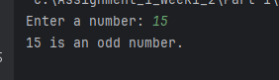

2. Write a program that prompts the user for two integer values and displays the results of the first number divided by the second, with exactly two decimal places displayed. [5]

Output:

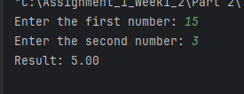

3. Write a program that will convert Celsius value to Fahrenheit.[5]

Output:

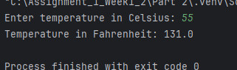

Write a program to find the Euclidean distance between two coordinates. Take both the coordinates from the user as input.[5]
Output:

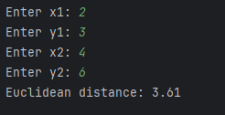

5.Write a program to find the simple interest when the value of principle, rate of interest and time period is provided by the user.[5]
Output:
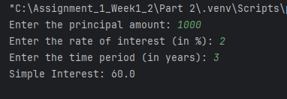

6. Write a Python program to find those numbers which are divisible by 7 and multiple of 5, between 1500 and 2000 (both included). [5]

Output:
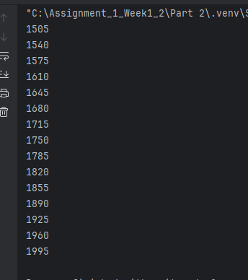

7. Write a Python program that accepts a string and calculates the number of digits and letters.[5]

Output:

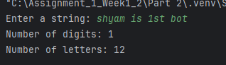

8. Write a program to create a number guessing game for the user. The program should ask the user to input a number. The program specifications are as mentioned below.
- The program should generate a random number for the answer.[2.5]
- The program should prompt the user for a number input.[2.5]
- The program should provide the feedback to the user after each guesses (e.g. “Too high”, “Too low” or “Correct number”).[2.5]
- The program should check the user input for 5 times and allow the users to guess for at most 5 times if their input don’t match the answer number.[2.5]
- If the user is not able to guess the answer within 5 times, the program should display “Game Over” message and exit. [5]
Output:

